Alignments without Low-Scoring Regions
Zheng Zhang, Piotr Berman and Webb Miller
RECOMB ’98 (Annual International Conference on Research in Computational Molecular Biology), pp. 294-301, 1998

Abstract
Given a strong match between regions of two sequences, how far can the match be meaningfully extended if gaps are allowed in the resulting alignment? The aim is to avoid searching beyond the point that a useful extension of the alignment is likely to be found. Without loss of generality, we can restrict attention to the suffixes of the sequences that follow the strong match, which leads to the following formal problem. Given two sequences and a fixed X > 0, align initial portions of the sequences subject to the constraint that no section of the alignment scores below –X. Our results indicate that computing an optimal alignment under this constraint is very expensive. However, less rigorous conditions on the alignment can be guaranteed by quite efficient algorithms. One of these variants has been implemented in a new release of the Blast suite of database search programs.
- Formalization of the Problem
The score s (π) of a path π is the sum of its edge weights.
Fix X 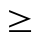 0. A X-path is a path that begins at 0 and has no segment of score strictly below –X.
Let 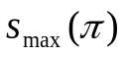 be the maximum score of a prefix of π, and let the terminal drop of π be tdrop(π) = 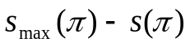. Then π is an X-path if it starts at 0 and tdrop(π’) 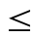 X for every prefix π’ of π.
- Finding All Vertices on X-Paths
Now our goal is to find Q(X), the set of endpoints of X-paths.
We have 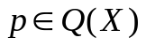 iff 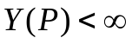
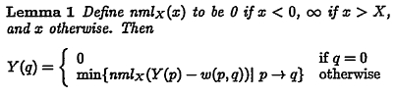
for each 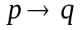
- Highest Scoring X-paths
To find for every vertex , a highest scoring X-path that ends at p. As a result, we can find the overall highest scoring X-path.
Let end(π) be the endpoint of π. An X-path dominates another X-path ρ－denoted if end(π) = end(ρ), tdrop(π) tdrop(ρ) and s (π) s (ρ).
We succeed in our goal if for every X-path ρ we find an X-path π such that .
This in turn is achieved by computing a set Π(X) with the following properties:
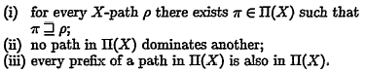
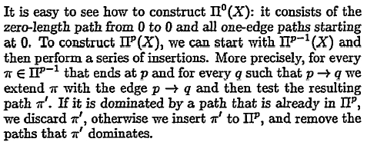
- X-paths That Are Optimal Paths
To find P(X), which is the set of all vertices one of whose optimal (highest score) paths is an X-path, and to determine that highest score for each vertex in P(X).
Let top(π) be end(π’), where π’ is the longest prefix of π with the maximum score.
We describe an algorithm that uses two data structures:
a queue Q that stores the vertices that we wish to process, and the set S of nodes that have been processed. For each node 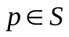 we store a record with two fields:
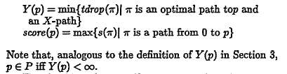

Date: Mar.19, 2004
Created by: Liang-Tai Wei

